**AI-Driven Exploration and prediction of company trends with register of companies(ROC)**

# Problem *Definition*

* Driven exploration and prediction of company registration trends is the process of using Artificial Intelligence.
* AI-Driven describes” a process that is powered by the capabilities of Artificial Intelligence”.
* Using Machine Learning and Data Analysis techniques to understand and forecast patterns in how companies are registered.

# *Innovation:*

The various creative AI initiatives in various sectors such as:

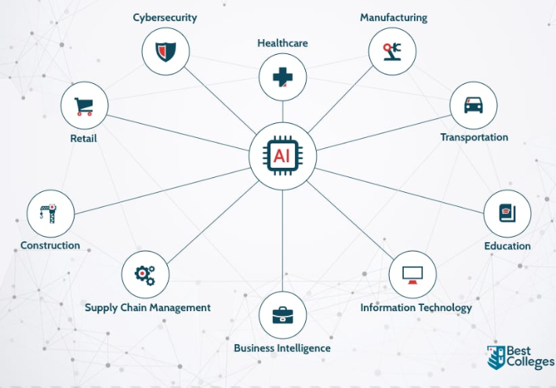

Design Thinking

Stage 1:

**Techniques**

For Designing Valuable tool for business,investors and policy makers using advanced machine learning and data analysis techniques

AI can,,….

* **Data Collection** - Gather a comprehensive dataset from various sources
* **Customization -** To specific use needs
* **Trend Analysis** - Analyse Historical data to identity patterns and trends in company Registration.
* **Predictive Modelling**  - Use your trained model to make predictions about future company trends
* **Visualization** - present data and prediction
* **Model selection** - choose appropriate machine learning models for prediction
* **Training Data** - Gather data on company registrations,use to validate your AI model.

Stage 2:

**Reqirements**

Model training -> feature engineering

Resource allocation -> training data

AI model selection -> Data visualization



## Stage 3:

**Ideas:**

Provide variables insights for various stakeholders

Some ideas to considered the growing level of the companies inorder to predict their sources or datas,…



# Stage 4:

**Idea to implement:**

Thus Economic Forecast to the Best idea for AI driven Exploration and Prediction company to the registration trends is…

Given below,…

Problem Solution:

* In conclusion,AI-Driven exploration and prediction of company registration trends is a powerful tool that can provide valuable insights and ahead of completion.
* By using AI Technology,companies can identity market shift and decisions with confidence.
* As we look to future,it is clear that AI will play an important role in decision-making.Companies that embrace this technology will be better to navigate an ever-changing marketplace and new opportunities as they arise.
* The benefits of AI-Driven exploration and prediction are too great to ignore,and I encourage all of you to consider how this technology can benefit your organisation.